1. Is Economic Freedom defined by how much money a country generates?

Not directly. As it turns out, it’s only one part of many that play into definition of Economic Freedom.

In exploration, we looked at 3 plots outlining various versions of Gross Domestic Product against the Economic Freedom Index (EFI) for each country. Population was used as an emphasizing factor for the bubble plots, specifically interesting in the Per Capita GDP plot.

GDP (Purchasing Power Parity in Billions USD) v EFI:

* Highest 5 GDPs listed in legend.
* Higher GDP is not correlated to higher EFI.
* Highest and 3rd highest GDPs fall below mean EFI.
* Most of the countries are clumped at the bottom 20% of the grid and are hard to differentiate.

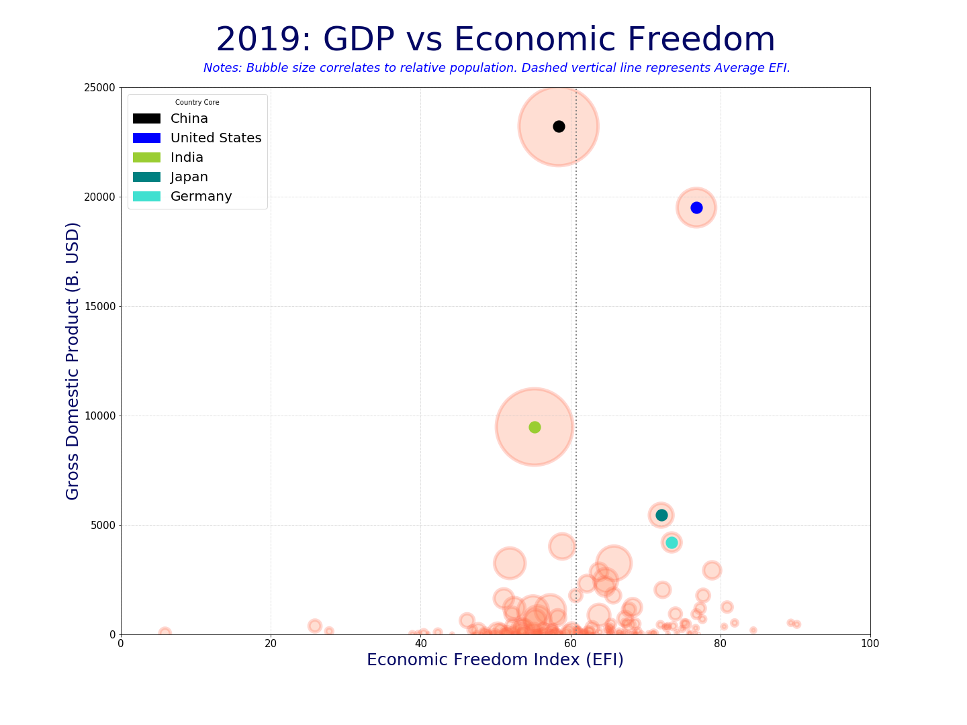

(continues)

Question 1 Continued:

GDP Rank v EFI:

* Different view of GDP, via rank order.
* Highest 5 GDPs listed in legend.
* Shows, again that higher GDP is not correlated to higher EFI.
* Still shows, highest and 3rd highest GDPs fall below mean EFI.
* Better representation of the rest of the countries distributed without the plot.
* Still reflects little correlation of GDP dollars to EFI.

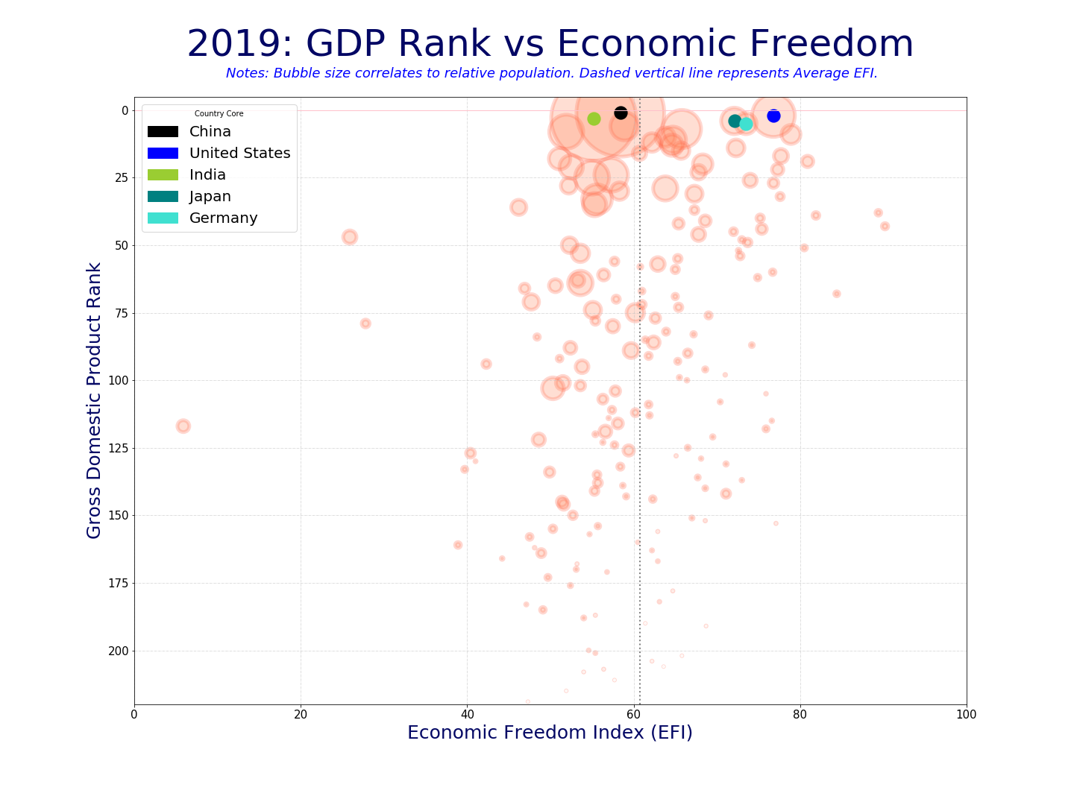

(continues)

Question 1 Continued:

Per Capita GDP Rank v EFI:

* Different view of GDP, via Per Capita Rank order.
* Highest 5 GDPs as reviewed in prior plots listed in legend.
* The ‘core’ 5 are different than the top 5 PCGDPs as seen by several points displayed higher (y-axis) on the plot.
* Interesting to see how China and India with such *huge* populations fall within the per capita display! Specifically China since they make significantly more than all other countries in GDP! That’s a LOT of people!
* Shows more correlation than the previous plots, since the distributions tightens in display, but is still quite wide with several outliers, lending to the fact that it is not a direct relationship.

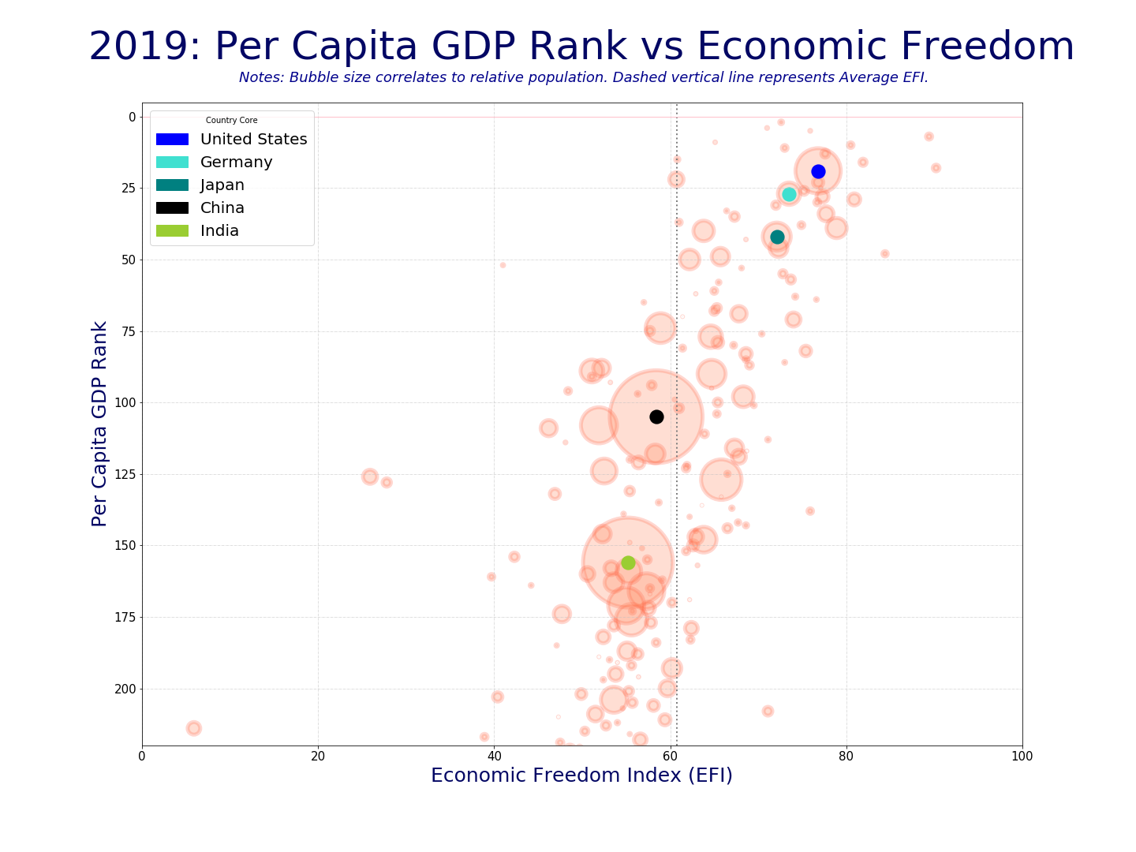

(continues)

1. What is the distribution of countries by class from Free to Repressed?

Results clearly displayed via the pie chart.

In our presentation, we listed the 6 countries that have scores allowing them to be classified as ‘Free’ (Australia, Hong Kong, Ireland, New Zealand, Singapore, New Zealand; in alpha order, not score order). We also mentioned that for 2019, 6 countries return as ‘No Score’ because they each had multiple missing factors resulting in no EFI calculations. However, we did not state which they were. (Iraq, Libya, Liechtenstein, Somalia, Syria, Yemen; in alpha order).

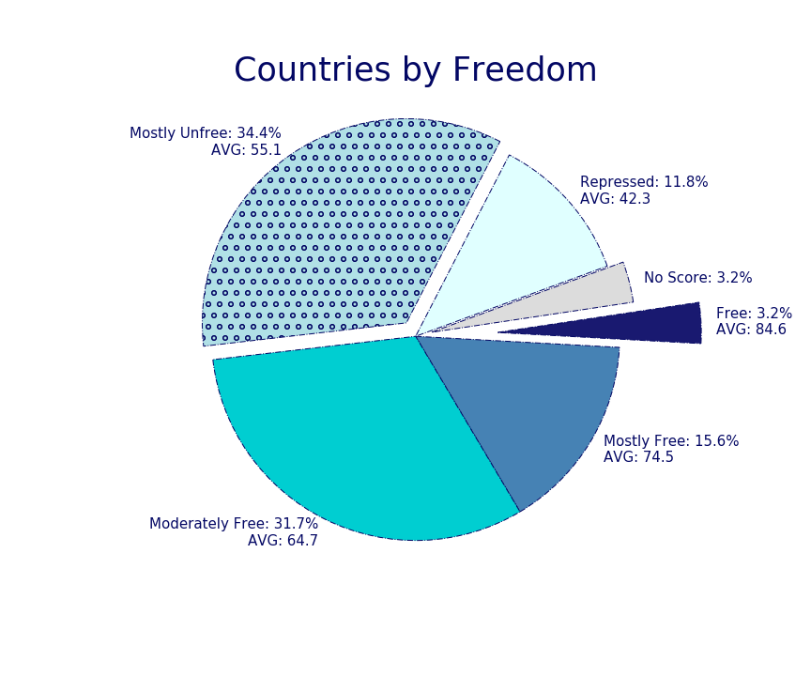

(continues)

1. How did average Economic Freedom scores change, by region, from 2010 to 2019?

* Europe has the highest overall freedom satisfaction for both years.
* Sub-Saharan Africa has the lowest average scores for 2010 and 2019 compared to other regions.
* The Americas were the only region that didn’t improve overall scores.

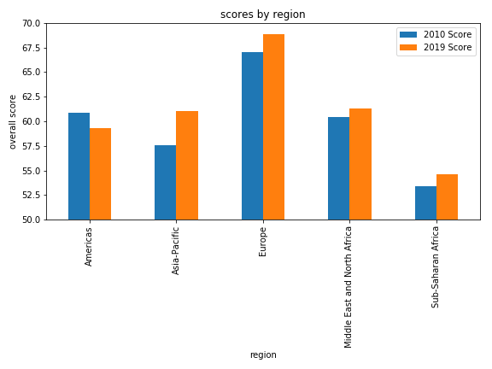

(continues)

1. How did the United States’ factors change, by year, from 2010 to 2019?

* Government spending satisfaction started and ended with the lowest score.
* The US seems to be most satisfied with our labor freedom.
* The trade freedom satisfaction category appeared to remain the most unchanged from 2008 – 2019.

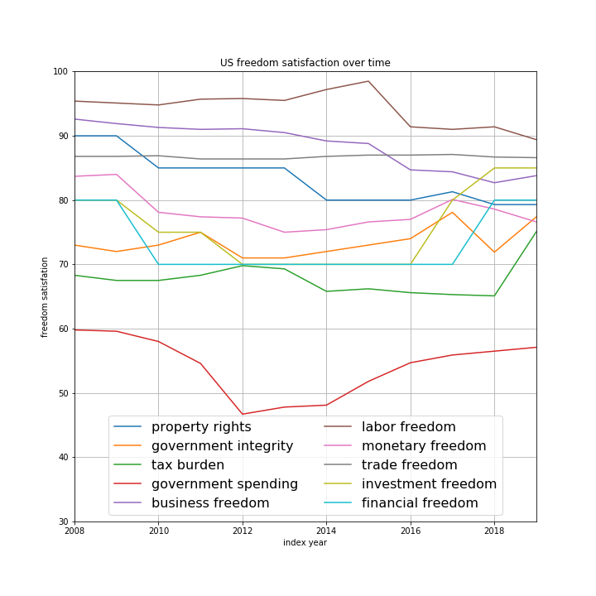

(continues)

1. Which factors drive Economic Freedom Index score globally?

**What factors have led the improvement in global economic freedom over the last decade?**

**Does it differ from the last 25 years (improvements led by Government Size and Open Markets Pillars)?**

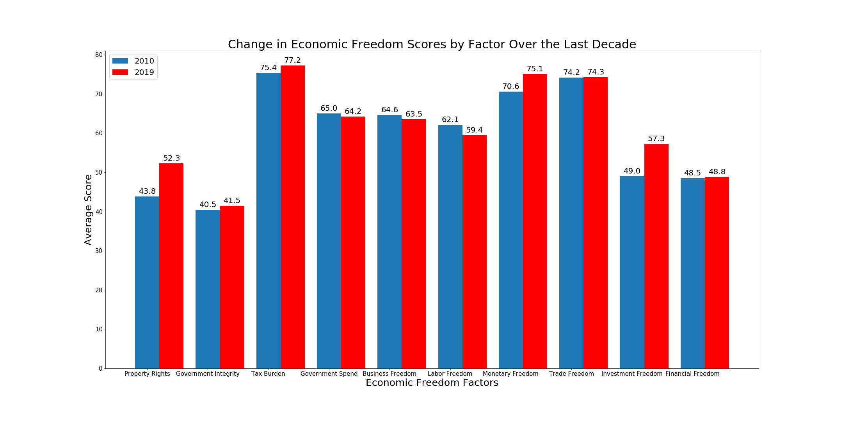

Growth in global economic freedom since 2010 has been led mostly by improvements in property rights, monetary freedoms, and investment freedoms. The three measurement factors that regressed over the last decade were government spend, business freedom, and labor freedom. The government spend category is no surprise considering its sole measurement is the level of government expenditures as a percentage of a GDP. Since the world had just begun its recovery from the global recession at the start of the decade, most governments were providing economic stimulus in an effort to fuel economic growth which in turn results in running larger budget deficits than normal.

From my perspective, I grouped property rights, monetary freedom, and investment freedom as more pertinent for high net worth individuals because these individuals tend to own more real estate, don’t generally have their wage growth correlated to the inflation rate (which has been lower than expected for the last decade), and actively invest their money in a variety of instruments both domestically and globally. Business freedom and labor freedom more directly affect the lower and middle class. The fact that the largest improvements in freedoms appear to more directly benefit the wealthy could be an interesting topic for further study to determine if that is truly the case.

This index has been around since 1995 and the majority of the economic freedom gains have come from the Government Size and Open Markets Pillars. However, based on the last 10 years, the Rule of Law Pillar seems to have replaced the Government Size Pillar. Considering the fact that the topic of national debt levels is more prominent in recent years, in not just the U.S. but many other countries, can help explain why the average score for the Government Size Pillar is stagnating. The other interesting part about this is Rule of Law is the only economic pillar to decline over the last 25 years, yet it has seen the largest increase of all the pillars within the last 10 years. This would be another issue to look further into if there was more time to work on the project.

(continues)

1. Which countries had the greatest change, both negative and positive, between 2010 and 2019?

NEGATIVE CHANGE:

**What countries had the largest percentage declines in their economic freedom scores over the last decade?**

**Were these countries in certain regions and not in other regions?**

**Did the score declines for these countries occur in similar economic freedom pillars?**

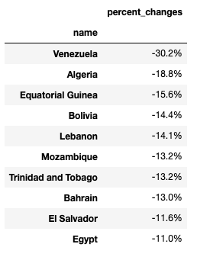

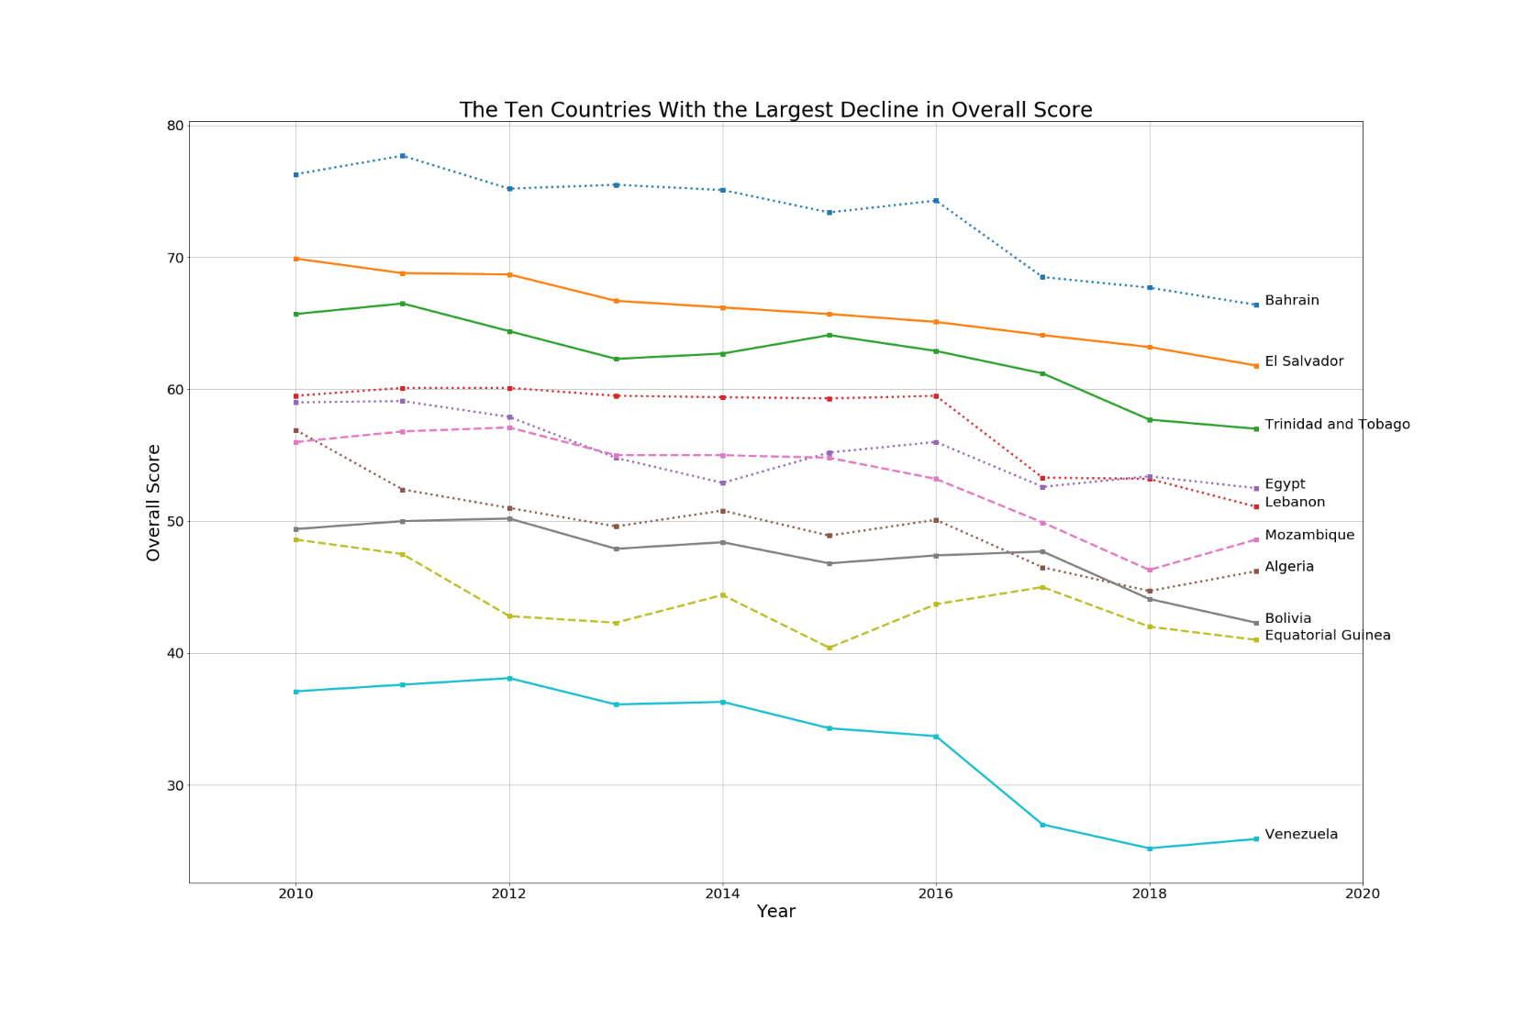

(continues)

Question 6 Continued:

NEGATIVE CHANGE CONTINUED:

The 10 countries with the largest percentage declines in their overall economic freedom scores over the last decade were concentrated in 3 of the 5 global regions. Four of the countries were in the Americas region (specifically Central and South America), four were in the North Africa and Middle East region, and the other two were in the Sub-Saharan Africa region.

When breaking down their scores, I found that the Regulatory Efficiency Pillar scores declined noticeably in 7 out of the 10 countries, specifically in the business freedom and labor freedom factors. The Government Size Pillar scores declined for 9 out of the 10 countries with the majority of the decline resulting from the government spending factor. Oddly enough, the opposite was true when it came to the Open Markets Pillar scores (trade, investment, and financial freedom) where 8 of the 10 countries actually experienced stability or even slight improvements. The Rule of Law Pillar scores were more in conflict because 9 out of the 10 countries experienced an increase in the property rights factor score, but 9 out of 10 countries experienced a decline in the government integrity factor score. These trends were fairly consistent with the rest of the world but just the score declines were more extreme in these countries and the improvements were minimal.

Of the 10 countries, 2 of them are rated “moderately free” (Bahrain and El Salvador) and the other 8 are rated either “mostly unfree” or “repressed.” Bahrain was the only country rated “mostly free” in 2010 out of these 10 countries.

(continues)Question 6 Continued:

POSITIVE CHANGE:

In reviewing the countries with the largest percentage increase in their overall score between 2010 and 2019 and their annual change in scores, Zimbabwe had the largest change at 88.8%. Although Zimbabwe has increased significantly up until 2018, they had a decline between 2018-2019. Either way they still rank as repressed in regard to economic freedom since their economic freedom overall score is less than 50.

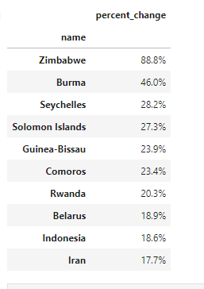

(continues)

Question 6 Continued:

POSITIVE CHANGE CONTINUED:

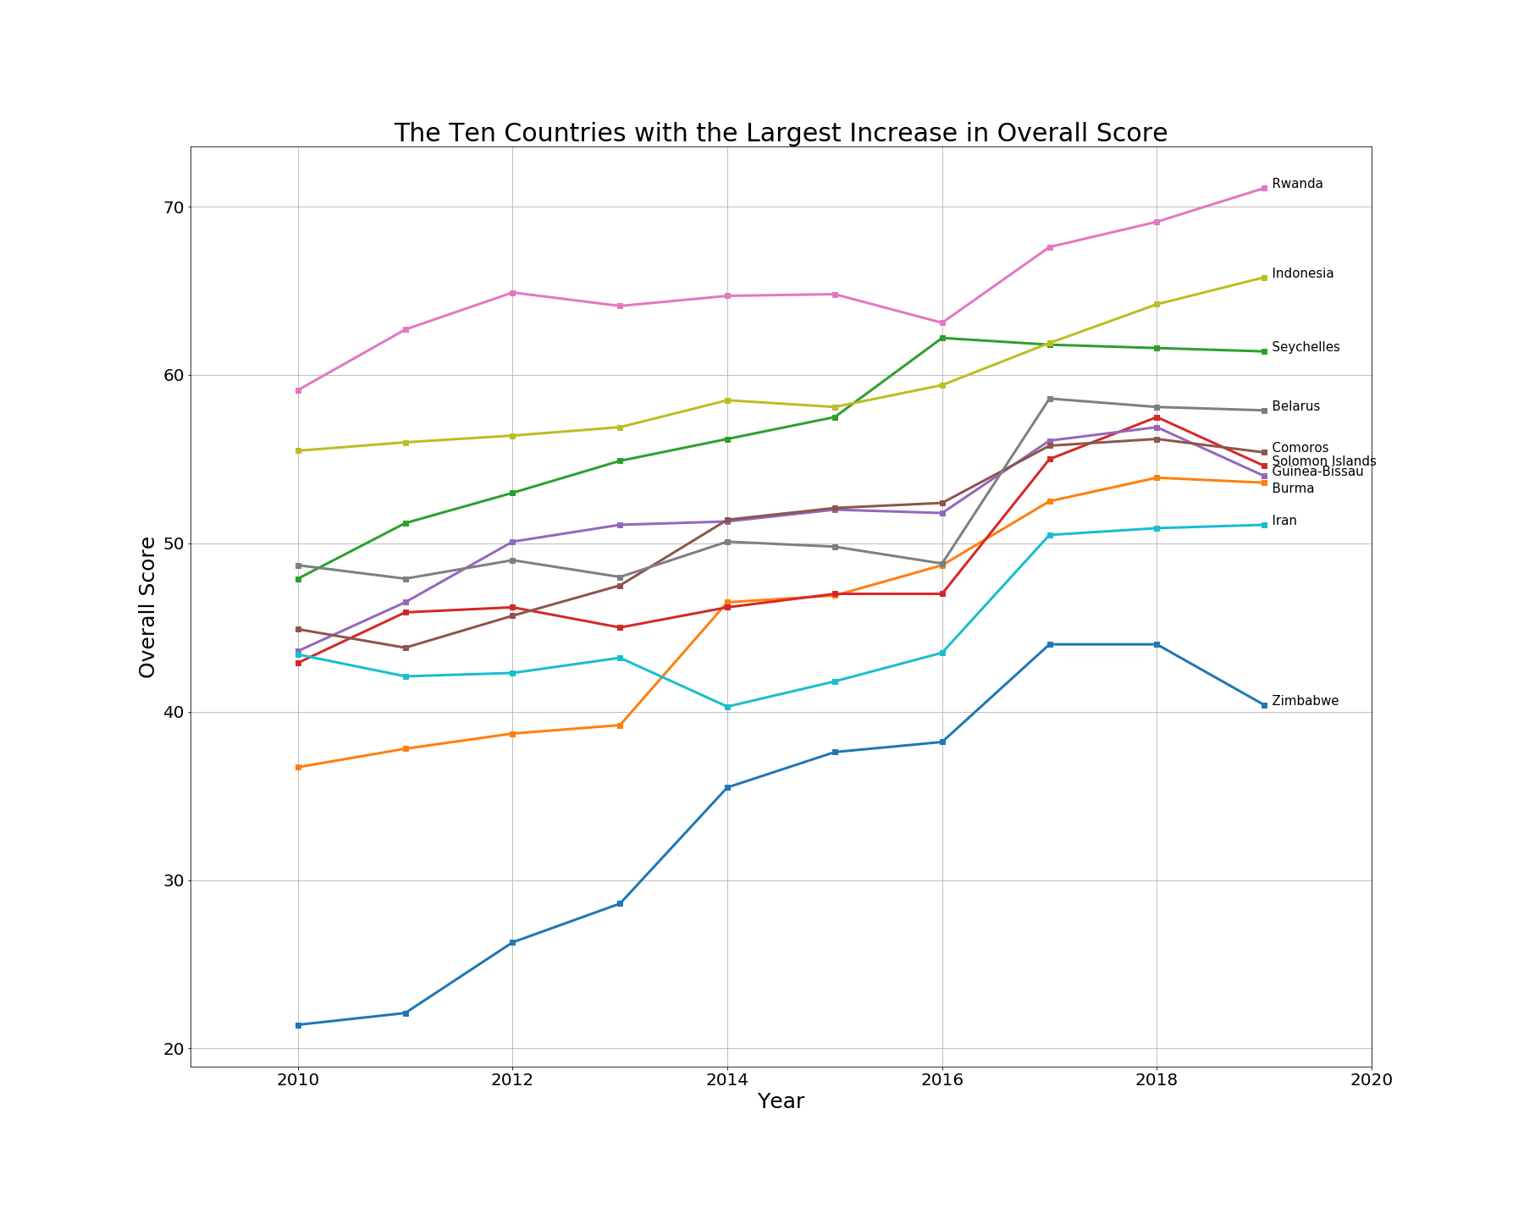

(continues)

1. Where does the United States fall in relation to highest and lowest countries?

Hong Kong had the highest economic freedom score while North Korea had the lowest score. The U.S. which is usually regarded as the leader in the free world is listed in a tie with the Netherlands at number 12. What will be interesting to note in the future is how the status of these three countries will change. Hong Kong is experiencing political unrest after becoming part of China. Will economic freedom decline?

Also, North Korea although at the lowest has had a slight uptick since 2016. Although still repressed it would be interesting to know which economic pillars accounted for the changes.

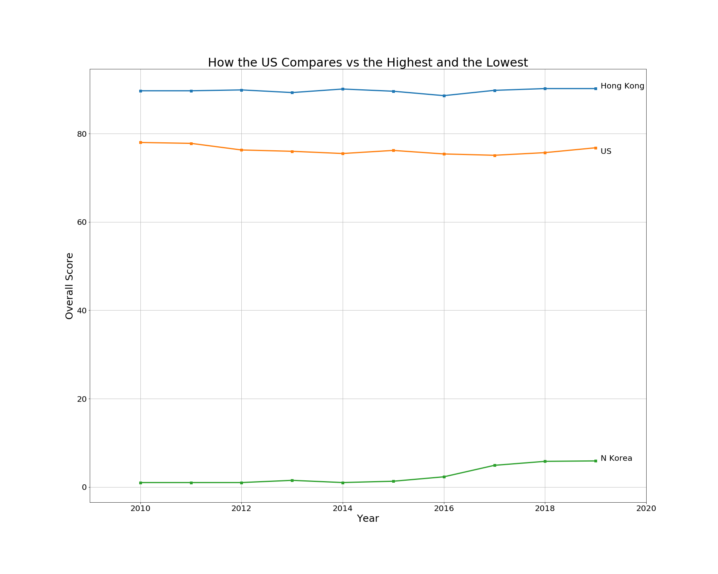(fin)